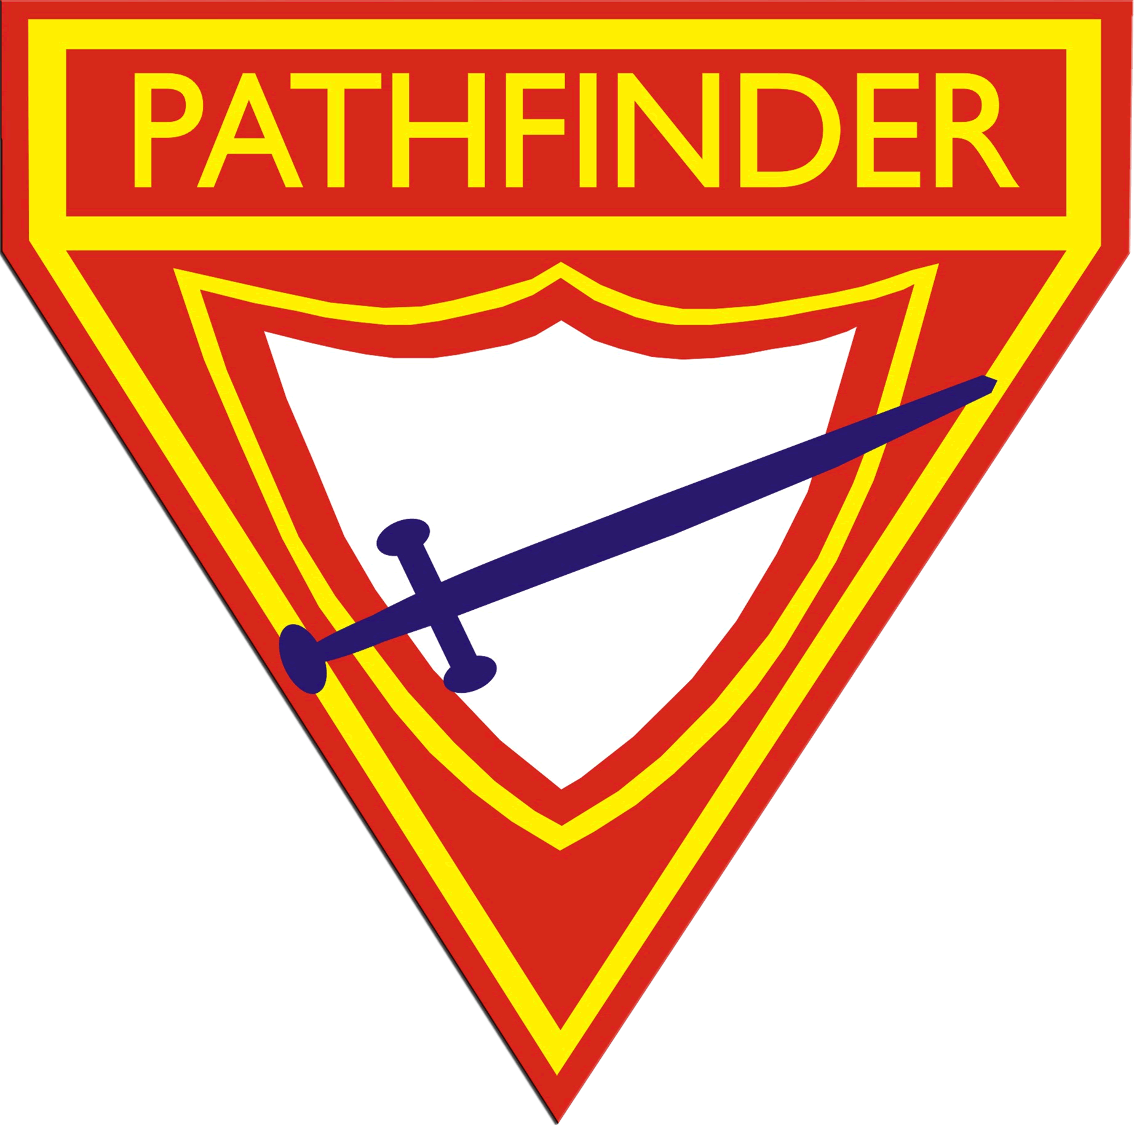
RISK ASSESSMENT
MANAGEMENT FORM
GENERAL
Pathfinder Club:
Name of appointed leader for event:
Name of person completing this form and contact details:
Date(s) of event:
Type of event:
Location(s) of event:
Brief outline of event:
Will your event include any of the following activities? If so, please advise details of activities and ensure that your RAMS form addresses the risk involved. | Hiking, Rock climbing, Abseiling, Water activities, Beach activities, Snow activities, Adventure activities, Remote locations, or other mid- to high-risk activities?
Possible weather conditions expected during event:
PATHFINDER PARTICIPANTS
How many pathfinders will be in attendance? (gender specific) | Males: Females: Total:
Number of pathfinders in each age group: | 6-12 years: 13-17 years:
PERMISSIONS
Have parents been briefed on event, its requirements and what to bring?
Has parent consent specific to the activity been completed?
Has the Church Board approved the event?
Is a permit required for this activity?
If yes, provide details:
EMERGENCY
Who is the emergency contact? | Name:  Phone:
Is this emergency contact aware of the agreed upon day and time they need to notify police, SES or VicYouth if they have not heard from the pathfinder club?
Will your emergency contact be provided with a full list of participants including: pathfinders, staff, underage children and vehicle registrations?
Will your emergency contact have a description of your planned activities as well as the location of the activities?
Nearest emergency services (incl. 24 hour) and phone number: | Police:  Address:  Phone:  Hospital 1 (may/may not include 24/7 emergency department):  Address:  Phone:  Hospital 2 (must have 24/7 emergency department):  Address  Phone:  Fire Brigade:  Address:  Phone:
STAFF
What skill and experience is required by leaders and staff?
Do all attending adults have WWCC? If not, advise how many do not have WWCC and the reasoning.
Have all attending adults completed Safe Church Awareness Training? If not, advise how many have not completed this training and the reasoning.
How many adults are trained in:
- First aid (min Level 2)
- Food handling / safety
- Avondale trained (or equivalent) base camping
- Avondale trained (or equivalent) bushwalking
- Other, please specify
What Adult : Pathfinder ratios are required for the event (noting ratios can vary for activities). Will these be adhered to?
EQUIPMENT
Is there a fully equipped first aid kit on site suitable for activity?
Is a mobile first aid kit taken with each group when away from main site?
Have the first aid kits been checked prior to the event to ensure they are fully equipped and items are ‘in date’?
When were the first aid kits last checked?
What communication systems will staff use (telephone lines at location, UHF radios, mobile phone, satellite phone, SPOT messenger etc.)
What electrical equipment or specific event equipment will be used / provided by the club?
Has all equipment been checked prior to the event to ensure that it isn’t faulty?
Is electrical equipment tested & tagged?
How will electrical equipment be protected from water?
ALLERGIES / ASTHMA & OTHER MEDICAL CONDITIONS
Do you have completed up to date medical information for all attending, including all attending adults?
Who will have access to the medical information of each participant and how can it be accessed during the event?
Are medical records kept safe, private and only shared with key leaders of your club? Explain.
What known medical conditions can be adversely affected by the event, what are the known triggers and how will these be managed?
Do staff have knowledge and training to identify and treat these specific conditions?
Is the first aid kit accessible and equipped for these known conditions?
COVID-19 MITIGATION
Are current Victorian Government guidelines* for your planned activity being followed?
*See updated guidelines here: https://www.dhhs.vic.gov.au/your-coronavirus-covid-19-questions-answered

Will appropriate boundaries be set and communicated regarding social/physical distancing for your planned activity/ies? Please describe:
How will hygiene practices be managed for the duration of your activity?
How else have you shown intentionality in mitigating the risk of COVID-19 transmission for your planned activity/ies?
INFECTION / DISEASE / VIRUS
Are hand washing facilities readily available and regularly cleaned?
Is hand sanitiser readily available?
Are participants allowed to share food and eating utensils? If so, how will spread of diseases be prevented?
If a participant has an infection / disease / virus at the event, how will this be managed?
Is there a risk of inadequate food storage that could lead to food poisoning? How will this be managed?
Are there any specific risks related to the event that can contribute to spread of infection / disease / virus? How will this be managed?
BITES & STINGS
Identify likely creatures that can bite or sting, which may be in the area where the event is taking place:
How will the event be managed to reduce the risk of bites and stings?
WATER INJURY INCLUDING DROWNING
Will you be camping near water (eg river, lake, ocean etc.)? If so, provide details of the location and advise how the risk of injury or drowning will be managed?
Will activities be run in / on the water? If so, provide details and advise how the risk of injury or drowning will be managed?
Will powerboats be utilised during the event? If so, provide details and advise how the risk of injury or drowning will be managed?
How many staff have current bronze medallion or lifesaving qualifications?
What boundaries will apply around water?
What specific hazards apply to this location & event (eg. submerged hazards / rips etc). How will these be managed to prevent injury or drowning?
What, if any, lifesaving equipment will be on hand?
Are there any participants with no or low swimming ability? If so, how will this be managed?
EXHAUSTION / DEHYDRATION / HEAT STROKE
What elements of the event can contribute to exhaustion / dehydration / heat stroke? How will this be managed?
How vigorous are the activities?
Is drinking water readily available for participants? If not, explain how the lack of water will be managed:
HYPOTHERMIA
Are cold weather conditions expected or a possibility?
What elements of the event can contribute to hypothermia? How will this be managed?
FRACTURES / SPRAINS / CUTS / ABRASIONS
Is there an active housekeeping policy in place?
Will the site have adequate lighting at night? Provide details:
What elements of the activity can contribute to fractures / sprains / cuts? How will these be managed?
What is the process in place to identify and manage hazards that can result in fractures / sprains / cuts?
BURNS (OTHER THAN SUNBURN)
Will there be a campfire at the event?
How will the risk of burns be managed?
What is the risk of bushfire? How will this be managed?
Will children be cooking? If so, how will the risk of burns while cooking be managed?
Will staff be cooking? If so, how will the risk of burns to staff and those near the kitchen area be managed?
What type of cooking equipment will be used?
Has cooking equipment been checked to ensure it is safe for use and not faulty?
Is there a fire extinguisher and fire blanket in the cooking area?
SUNBURN
Will sunscreen be supplied?
Will shade be available at all times? Provide details:
How will risk of sunburn be managed?
MOTOR VEHICLES
Are all vehicles roadworthy?
Are all vehicles registered?
Will P plate / inexperienced drivers ferry underage participants? If so, how will the risk of accident due to inexperience be managed?
Will vehicles be moved / used regularly? If so, how will the risk of accident with a vehicle be managed?
Are there any specific elements of the event that can increase risk of accident in / with a vehicle? If so, provide details and advise how this will be managed?
LOST
What elements of the event could allow participants to become lost or unaware of their location? How will this be managed?
Does the event have a day walk activity? If so, what is the experience and qualifications of staff leading the day walk activity?
Does the event have an overnight hiking activity? If so, what is the experience and qualifications of staff leading the overnight hiking activity?
How remote is the location where the event is being held? Include details:
If a group became lost, what weather conditions are expected?
If a group became lost, what is the level of difficulty for search and rescue? How will this be managed?
PERSON SAFETY / PSYCHOLOGICAL TRAUMA
Is there an active no bullying / discrimination policy in place? If not, provide reasoning:
Is the event in a public area?
Is a high volume of public expected to be in / near the event area? If so, how will risk be managed?
What is the process for managing safety around toileting?
What process is in place to manage a trauma incident?

Risk matrices
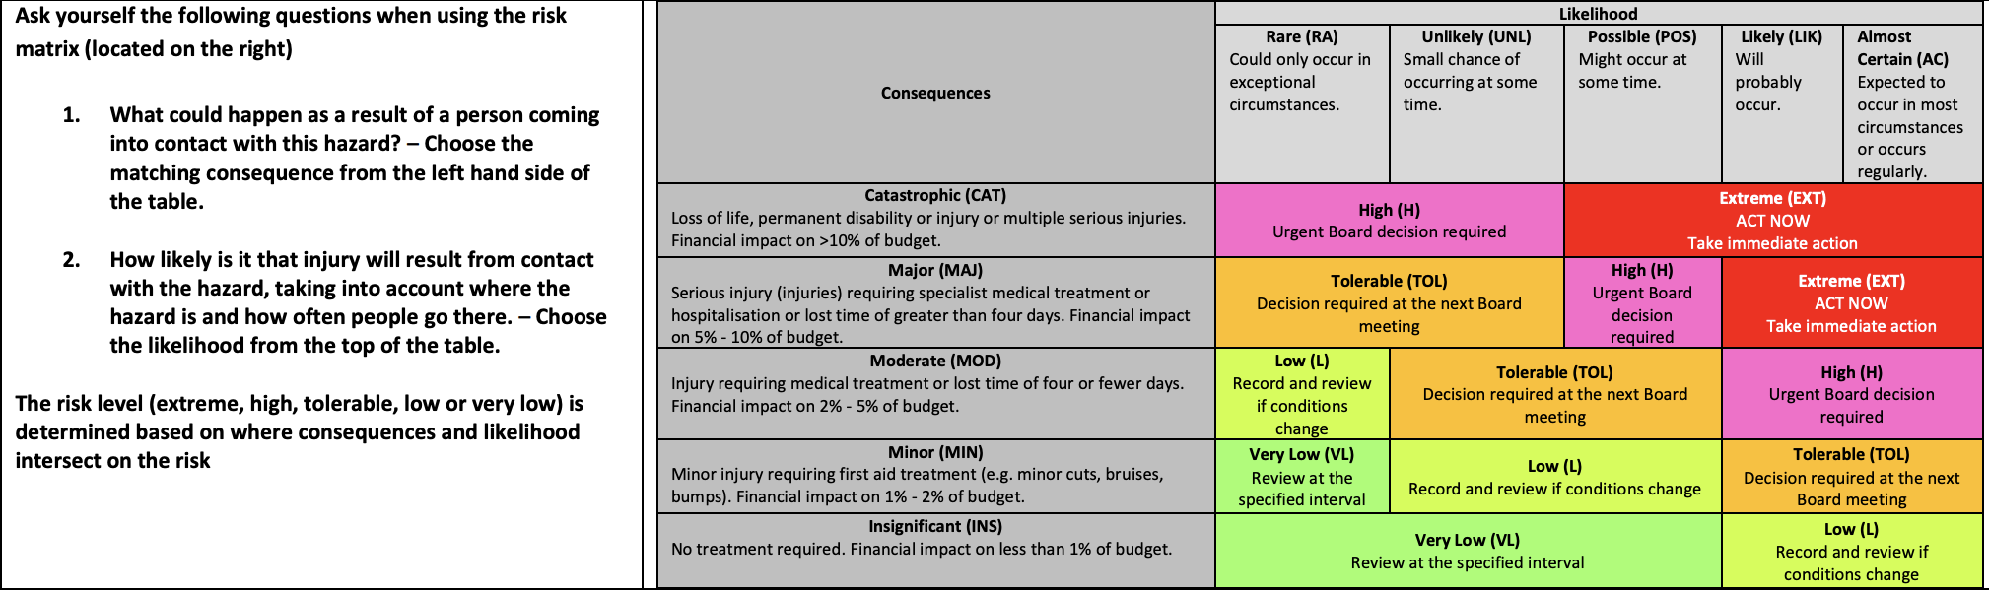
Score | Action
Extreme (EXT)  Stop and Act | Immediate action required. The proposed task or activity must not proceed until steps are taken to lower the risk level to as low as reasonably practicable using the hierarchy of risk controls.
High (H)  Act Today | Activity can only proceed if action is taken today to:  - reduce risk level as low as reasonably practicable  - risk controls must include those identified in legislation, Australian standards, Codes of Practice etc  - the risk assessment has been reviewed and approved by the supervisor  - a safe working procedure and method has been prepared and communicated to all parties involved in the activity  - the supervisor reviews and documents the effectiveness of the implemented risk controls
Tolerable (TOL)  Proceed with Caution | You may decide to proceed with caution provided that:  - risk level is as low as reasonably practicable and tolerable.  - risk assessment has been reviewed and approved by the supervisor
Low (L)  Proceed and file | Activity may proceed and documentation of controls kept on file.
Very Low (VL)  Proceed and file | Activity may proceed and documentation of controls kept on file.

